***School of Electronic Engineering and Computer Science, Queen Mary University of London***

**FINAL YEAR Interim Report and Risk Assessment**

**Session 2016-17**

***This project specification must be undertaken in consultation with your supervisor. The feasibility of the project should have been assessed and the project aims should be clearly defined.***

***Submission of this document implies that you have discussed the specification with your supervisor.***

|  |
| --- |
| **Project Title: Reservation Database System with Analysis**  **Supervisor: Dr. Pengwei Hao**  **Student name: Chieh-Yu Chou** |
| **Student Email: c.y.j.chou@se14.qmul.ac.uk** |

**Student Contact telephone number: +44 7871283175**

Background Literature

**Restaurant Reservation Database System and Analysis Tool**

The end system will require a Database Management Systems (DBMS), which not only enable the restaurant consumer to book the table but also the restaurant manager can review the data. DBMS is a collection of programs that enables you to store, modify, and extract information from a database (Vangie Beal, 2005). The DBMS provides users and programmers with a systematic way to create, retrieve, update and manage data (Margaret Rouse, 2015).

Resources Consulted

Two questionnaires have been designed from me, one questionnaire is used to collect user’s usage experience on restaurant booking system, the another one is answered by restaurant manager/staff for the analysis tool system.

As the questionnaires conducted, there are some requirements must be included in my end system:

* Functional requirements:
  + Self-Queuing System
  + Pre-Order System
  + Confirmation Message via E-mail and Text message
  + Remind Message
  + Only Present and Future Dates/Times can be selected
  + Updated/Insert booking information immediately
  + Compare and Contrast
  + Search Bar
  + Graphic Presentation
* Non-Functional requirements:
  + User Interface
    - Colors
    - Text font
    - Assist/Tips
    - Friendly feedback
  + Browser Compatibility
    - Smartphone
    - Tablet
    - PC/laptop
  + Privacy
    - Terms and Conditions

The end system will carefully follow those requirements for booking and analysis system.

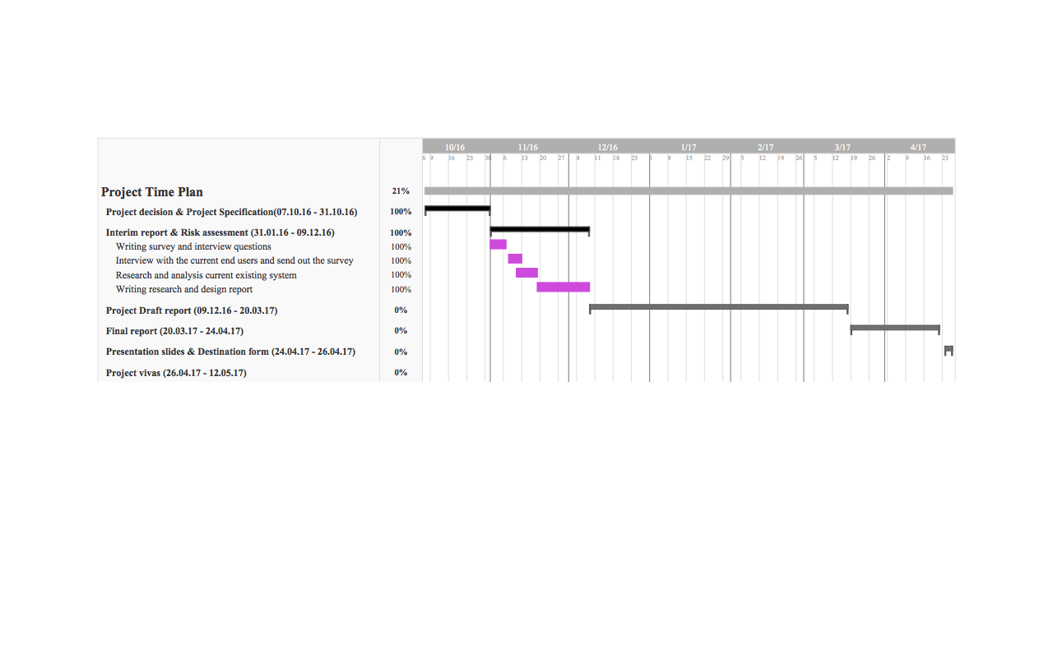Summary and Review of Progress

Interview, Questionnaire, Research and Analysis current existing system has identified the pros and cons of the existing systems. By doing this, it has not only shows the user’s experience of using the system, but also illustrates what functions developed a good end system.

Researched current existing systems:

* Official restaurant booking systems:
  + Duck&Waffle
  + Kintan
  + Patisserie Valerie
* Second party systems for booking tables or order/deliver foods:
  + OpenTable
  + Just-Eat

As the resources consulted shows the customers and manager’s requirements, additionally interviewed with server restaurant customers and managers have also agreed with those requirements must be included in the end system.

Work plan for semester 2

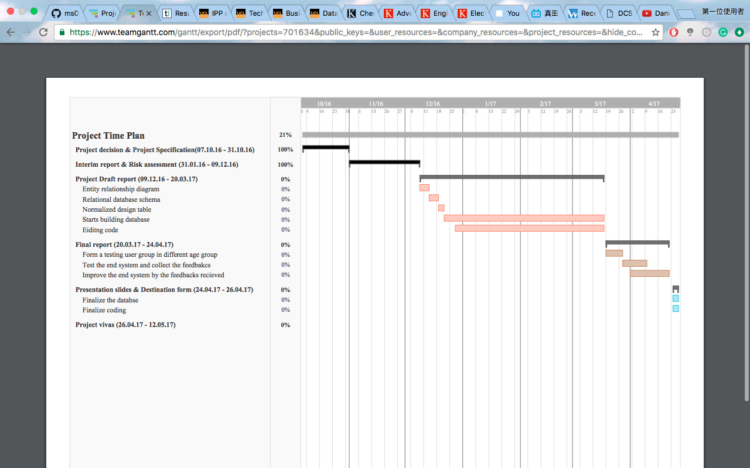The diagram below is the work plan for semester 2, I will spend the majority of the time on developing/coding the end system, each week I will note down a short review progress and meeting with my supervisor once a week or twice a week.

Nonetheless, the testing progress will involve different ages groups, thus during my questionnaire at the last question I had kindly asked people who take the questionnaire also want to become a member of the testing end system crew. Therefore, during the testing periods, I will provide them end system and they can play it around, if there is any bugs or errors, they can send me the feedbacks, moreover, if they come up with some new requirement, I will take a careful consideration to including in the system or not.

After the debugging periods, I will move on to finalize the database, i.e. remove all the testing data which had imported to the database, and finalize the coding, i.e. make sure the feedbacks, comments or advice that I had to make the adjustments to the end system.

After each process, I will generate a report either in text or graphic form, and simultaneously I will be building up my final report, presentation slides and prepare for the presentation.

Risk Register

There are two risk registers at below, one risk register is for Restaurant Booking System and the another risk register is for Restaurant Manager Analysis System.

Restaurant Booking System

|  |  |  |  |  |  |
| --- | --- | --- | --- | --- | --- |
| RiskID | Description of risk | Description of impact | Rating | | Preventative actions |
| Likelihood rating | Impact rating |
| 1 | Missing to insert the booking data input from customers to end system | The restaurant will have no detail of booking data when the customers arrive. | LOW | HIGH | Update the database immediately after the customers has booked the entire. |
| 2 | Missing to send a confirmation message via text or email to different customers. | This will cause the confusion. | LOW | MEDIUM | After the customer has hit the booked or any confirm button the system should immediately send a confirmation message via the options customer had chosen. |
| 3 | System not update the booked and available table on time | This will affect the loss of customers and inconvenient system for customers. | MEDIUM | HIGH | Solution same as RiskID 1. |
| 4 | System not send the auto-queue number via text correctly | The waiting customers will have the confusion. | MEDIUM | MEDIUM | When the customers require a self-queuing service at the restaurant, the staff should take their phone number and insert into the system directly. |
| 5 | System allows user to select booking date in past | The customers have a chance to book the table at the past. | LOW | LOW | Disable the selection of past date, only the present and future date will can be selected. |

Restaurant Manager Analysis System

|  |  |  |  |  |  |
| --- | --- | --- | --- | --- | --- |
| Risk ID | Description of risk | Description of impact | Rating | | Preventative actions |
| Likelihood rating | Impact rating |
| 1 | Failure in represent selected data in graphical form | The end user (manager) will not be able to compare and contrast the data. | LOW | HIGH  Why | Enable the data can be selected from any row and column. |
| 2 | Failure in search data | Require more time to find old data. | MEDIUM | MEDIUM | Add in the functions allow the end users to search data in UPPERCASE or lowercase letter. |
| 3 | User can edit the past date (old) data | The data realist will decrease. | LOW | HIGH | Set the table as view only, thus the end user will not be able to edit the data. |

Identify

Risks to successful completion of my project:

1. Fail to implements the requirements from the research I have done.
2. During the coding periods, I spend too much time on it, so less time can finalize the code/project.
3. During the debugging periods, I had few errors do not know how to solve.

In order to solve those risks, I will:

1. Note down each issue I got at every process.
2. If the requirements are difficult to implement, I will make some adjustments.
3. Find a solution by myself first.
4. Discuss with my supervisor if I cannot find the solution.